P250/1

**GEOGRAPHY**

**(Physical Geography)**

PAPER 1

**Jun. Jul. 2024**

3 hours

Uganda Advanced Certificate of Education

**GEOGRAPHY**

(PHYSICAL GEOGRAPHY)

**Paper 1**

3 hours

**INSTRUCTIONS TO CANDIDATES:**

*This paper consists of* ***three*** *sections* ***A, B*** *and* ***C***

*Answer* ***FOUR*** *questions in all.*

*Section* ***A*** *is compulsory*

*Answer* ***one*** *question from section* ***B*** *and* ***one*** *from section* ***C****.*

*Any additional question(s) answered will* ***not*** *be marked.*

*Credit will be given for the use of relevant sketch maps, diagrams and specific examples studied in the field.*

**SECTION A**

Questions **1** and **2** are compulsory

1. **COMPULSORY MAP WORK QUESTION**

Study the 1:50,000 East Africa **(UGANDA) KAMPALA** map extract, part of sheet 71/1, series Y732, Edition 3 – USD and answer the questions that follow:

1. (i) What is the grid reference of the primary trigonometical station

on Naguru hill. (01 marks)

(ii) Name the relief feature found at grid reference 619302. (01 mark)

1. Calculate and state in square kilometers the area occupied by Lake Victoria to the South of Northing 31 between Eastings 59 and 64. (02 marks)
2. Reduce the area shown on the map extract by 2/3 and on the reduced frame mark and name;
3. Any two physiographic regions
4. Any two drainage features
5. Two vegetation types. (10 marks)
6. Calculate the;
7. New scale of the map drawn. (02 marks)
8. Vertical interval for the map extract. (01 mark)
9. Describe the relief of the area shown on the map extract. (08 marks)

1. **COMPULSORY PHOTOGRAPH INTERPRETATION QUESTION**

Study the photograph provided below and answer the questions that follow:-

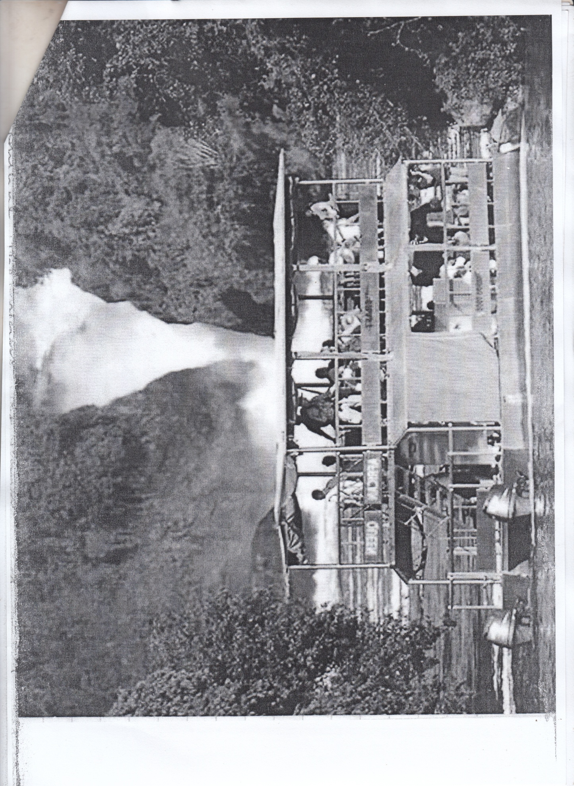

1. Draw a landscape sketch of the area shown on the photograph and on it mark and name;

* Two relief regions
* Two vegetation types
* Water fall
* Plunge pool (09 marks)

1. Account for the formation of the following;
2. Waterfall (05 marks)
3. Plunge pool (05 marks)
4. Outline the value of the drainage landforms in (b) above to the national economy. (04 marks)
5. Giving reasons for your answer, suggest an area in East African where the photograph could have been taken. (02 marks)

**SECTION B**

**Answer one question from this section**

1. To what extent are highlands a result of denudational processes in East Africa?

(25 marks)

1. Examine the influence of glacial erosion on the formation of relief features in East Africa. (25 marks)
2. (a) Distinguish between positive change and negative change. (06 marks)

(b) Explain the formation of landforms resulting from submergence of

Coastlines. (19 marks)

**SECTION C**

**Answer ONE question from this section**

1. (a) Distinguish between environmental lapse rate and temperature

inversion. (09 marks)

(b) Explain the conditions that have influenced temperature inversion in East Africa. (16 marks)

1. Account for the distribution of natural forest vegetation in East Africa.

(25 marks)

1. To what extent is the development of Latosols influenced by climate?

(25 marks)

**END**